**IFT 266 Introduction to Network Information Communication Technology (ICT)   
  
Lab 22**

**VLSM + DHCP**

Co-authored by Erik Mack

**After you complete each step, put a ‘√’ or ‘x’ in the completed box**

**Or**

**Insert a screenshot where required.**

**Objective**

Make a subnet that saves as much address space as possible for 5 hosts and have a DHCP server give the pool of addresses out to a few host computers.

Our initial IP address block given by our ISP is 192.168.0.0 with a /16 mask

1. Create the following topology in packet tracer, no addressing is needed at this point yet.   
     
   Make sure to add wireless capability to the laptop.

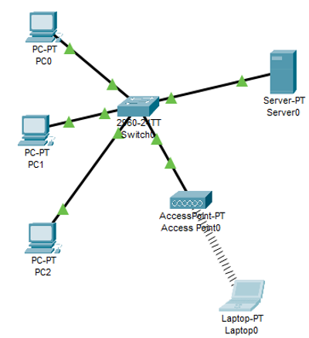



1. Configure the DHCP server with the IP address 192.168.0.1 and the default subnet mask.   
     
   Now find the host range for this subnet that this IP address (192.168.0.1) resides in and use a subnet that will save as much address space as possible for the 5 hosts.   
     
   What will be the usable range AND subnet mask?

1. Go back into the DCHP server and update the subnet mask with the new value that you worked out in step 2.



1. Now go to the services tab and select “DHCP”. We will start IP address at 192.168.0.3 and configure the gateway to 192.168.0.2 (this will get set on the router shortly).  
     
   Once configured, make sure to set the service to “on”.   
     
   We left out .1 for the dhcp server and .2 for our gateway.

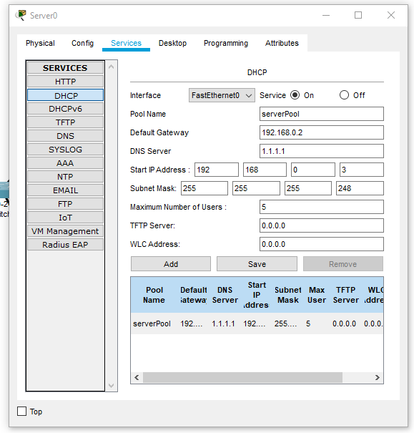



1. Go to PC0 and go to the desktop tab, from there, IP configuration. If we configured our network correctly, we should be able to obtain an address from the DHCP server.   
     
   Go ahead and select DHCP and the IP should be automatically configured, if not, troubleshoot.



1. You should be able to ping PC0 to the Laptop0 (the laptop has DHCP enabled by default), and PC0 to the DHCP server.

Insert **two** screenshots of your successful pings below.

So far, so good…

You have now fit an address to use 5 hosts in a network and have the DHCP server allocated the addresses.

1. We will now set up DHCP on a router for another piece of the network.  
     
   This network needs to support 2 hosts, one router and one PC 192.168.0.8/30 255.255.255.252

Update your existing packet topology as shown below.

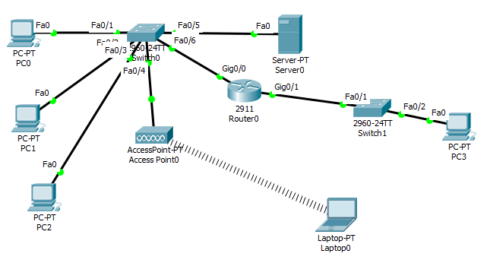



1. Now we will configure the DHCP pool on the router

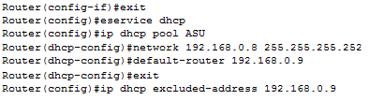

Notice how we excluded an address?   
This is for our router so in theory, PC3 should get an IP address of 192.168.0.10.   
Make sure to assign the excluded IP address to the router interface (g0/1)



1. Configure PC3 to receive their IP address dynamically.  
     
   It should receive the IP address: 192.168.0.10, if not troubleshoot.

Insert a screenshot of PC3 address configurations below

1. Go back into the router and assign it the 192.168.0.2/29 on the g0/0 interface.



1. You should now be able to ping PC3 from PC0, if not, troubleshoot.   
     
   Insert a screenshot of the successful ping below